1. Rename Boards to Departments everywhere => Done
2. Add an option to delete the boards / departments => Done
3. City should not be a dropdown on the sign up form, States should be a dropdown => Done
4. On the employee register change the text to “Employees added by organisation” => Done
5. We need to stop page refreshing all the time when we save forms and just use toastr notifications
6. Toastr notifications are working in some places and not working on other pages
7. The page loadtime is very slow , need to improve load times
8. Choose image on employee signup page does not work => Done
9. Need an option to delete a shift => Done
10. Add an option YTD (Year to date) on income summary on organisation profile. (Call me to discuss this further)
11. Have an Identifier on top of the page to say which Branch / board we are on while adding shifts. => Done
12. Sort the shift list in chronological order
13. Add identifying features for their skills and define which boards they are qualified to work for
14. [Peter.smith@gmail.com](mailto:Peter.smith@gmail.com) is still inactive => Done
15. 12:00 AM should be represented as 00:00
16. Cannot change shift time once it has been defined, we need to be able to change shift times
17. Create PDF button is still pointing to your XAMPP instance, canoot create PDF => Need to get the path where htmltopdf package installed
18. Share to facebook comes up with CakePHP Errors => Need to get the path where htmltopdf package installed
19. Whenever you add someone to a shift, the page does not refresh neither does it show the person on the calendar view, please make it so that it shows them in the calendar as we add them => Done
20. If a person is not available for a particular time slot or a day, the system should pop up a message saying “This employee is not available to work from 12:00AM to 3:PM” => Done
21. Also have an option for user to select shifts that are predefined in that organisation that they can or cannot work from the availability page.
22. Add board schedule overview in dashboard as a widget
23. On the textbox fields only add the basic customisation options like Bold or bullet points.
24. Reviews are not working. When I add a review or a warning and then I click on history I cannot see the reviews of that employee. => Done
25. The time range on Make permanent does not give you a time selector and throws an error when you press submit after selecting days
26. On an employee’s profile under Shift history section, add a dropdown to select:
    1. YTD (Year to Date) [This means all the time worked from the start of the financial year]
    2. This Pay Cycle
    3. From the start of Employment
27. Add an option for the organisation to edit the employee profile and when it’s saved the user gets an email with the changed information and also mention “If you think this change was an error, please contact the management immediately” in the email.
28. On Holiday Page, If you add a holiday and select All branches, It should only come as one. => Done
29. Have a function to import a Calendar CSV for public holidays from here: => Done  
    <https://data.gov.au/dataset/australian-holidays-machine-readable-dataset/resource/0f94ad45-c1b4-49de-bada-478ccd3805f0>
30. Add an option “Always” when you add payment factor type instead of selecting From and To
31. Display Payment factors in List rather than boxes for Payment factor. Just show a box of branches and list the factors in them as a list.
32. How is Organisation Role used? How does this fit into the whole system?
33. Use Notice Board for Branch and News for the whole organisation
34. On Messaging have these features: => Done
    1. Organisation:
       1. can send messages to Everyone on the organisation
       2. Can send message to everyone on a specific board (Department)
       3. Can send a message to an individual
    2. Managers:
       1. Can send message to other managers
       2. Can send messages to employees of his board only
    3. Employees:
       1. Can send message to their managers only
       2. Cannot send messages to anyone else
35. When you get a feedback from an employee, their profile picture is wrong.
36. Add the ability to change the status of the feedback to Complete, Resolved, In Process etc
37. Add the ability to forward feedback to another user by selecting the board and then selecting the manager or emp0loyee of that board.
38. On leave Page
    1. How do I setup Leave types?
    2. We need the following leave types: => Done
       1. Annual
       2. Sick
       3. Unpaid
       4. Compassionate
       5. Bereavement
    3. Change the text “Hospital Document” to “Supporting Documentation” => Done
    4. Set an option in the organisation settings page to define the Leave calculation factor per hour worked not including overtime hours.
39. Reviews page does not list the items properly. Reviews should be viewable on an emplyee’s profile directly. We actually don’t need a review’s page by itself. => Done
40. Add an option when you add a user to define a review time in terms of X week or X month or Annual starting from their enrolment date.
41. Shift Assign does not work, It says saved but nothing happens
    1. Move Shift assign under shifts => Done
42. Add the ability to attach a job description ot a particular shift
43. Remove To Do Task from the menu and have a dashboard TO DO list and the link on the dropdown menu on top => Done
44. On Emergency Procedure the types should be:
    1. Contacts
       1. We already have a feature of adding in contacts so leave it as it is
45. Add a week/fortnight cycle instead of from/to date in Shift history as well as on the form to create automatic shift plans (Call me to discuss about this in detail)
46. On Shift expenses, add a function for the user to attach a receipt for all the expenses they add. But the receipt upload should not be mandatory.
47. On the app on your calendar, tap on a date where you have a shift, then a option box should come up with swap option
48. Add a dropdown to select “Department” in Today’s Shift widget in Dashboard => Done

Additions after meeting on the 8th December

A trial account of a completion site <https://590224.wheniwork.com/login> has been set up. The user email is [jkaram505@gmail.com](mailto:jkaram505@gmail.com), the password is System505. Please jump on and take a look around. These guys have been at it for a while and they have a massive market share. We need to match what they do and exceed them. They have some really great features and ways of doing things that we can mimic.

1. Change the lay out of the page similar to When I work (WIW). Can this be done first so we can get a better feel of how the flow will progress.
   1. The main drop down tab groups are across the top of the page.
   2. Then the control features of each page are on the left when opened and required.
2. Tab groups to start off with:
   1. Employee Management
      1. Manage employees
      2. Staff trading
      3. Holiday
      4. Leave
      5. Leave management
      6. Reviews
      7. Job agreements
      8. Inductions
   2. Shifts
      1. Manage Shifts
      2. Assign shifts
      3. Shift expenses
      4. Organisation shift history
   3. News Board
      1. Notice board
      2. Message
      3. Feedback
   4. Logged in User
      1. My Profile
      2. My Schedule
      3. My Availability
      4. App settings
      5. Switch accounts
      6. Logout
3. Adding new employee:
   1. Date of Birth selection – need a better way of selecting. Currently it is just a standard calendar option.
   2. Wage per hour – have an option to select ‘’Salary’’. This would be for management positions. This amount is then to be calculated to an hourly rate. This figure can then be use for other processes within the program. Salary divided by 52 weeks of the year, divided by 40 hours per week = hourly rate. So if salary was selected, a new field would then pop up that would give the hourly rate calculation.
   3. Employment type: permanent or temporary, this can be used to set a priority for selection, as the permanent staff need to be given work first. If this will not happen, then we can skip this field and just go with the wage per hour figure.
   4. Auto population of address: change the wording of zip code to postcode.
   5. When you press ‘enter’ from having the cursor in the Designation, it jumps to Wage per hour field.
   6. When you press ‘enter’ from having the cursor in the Email field, it jumps to Date of Birth.
   7. Have to hit submit button twice to process new employee data.
   8. Add a field for licences, vaccinations, or any other work related requirements. The date and validity can then be stored and an alert can be triggered and sent to employee and supervisor.
   9. As per screen shot from WIW,

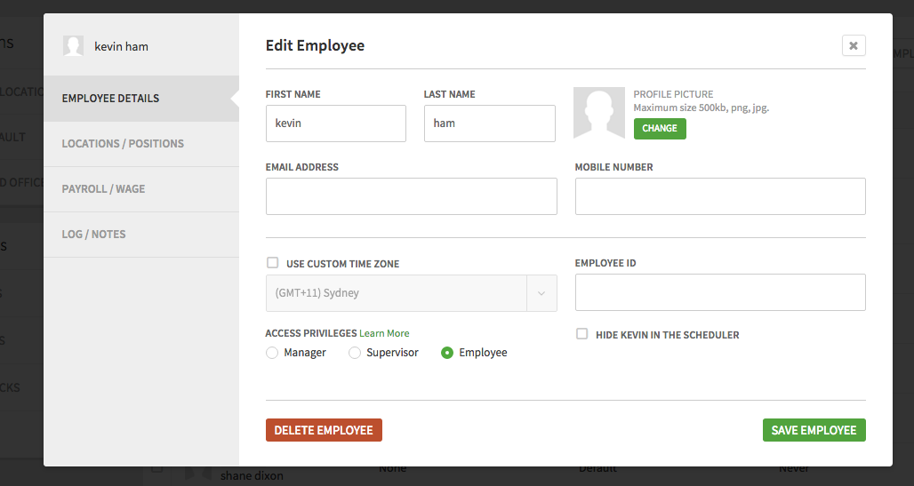

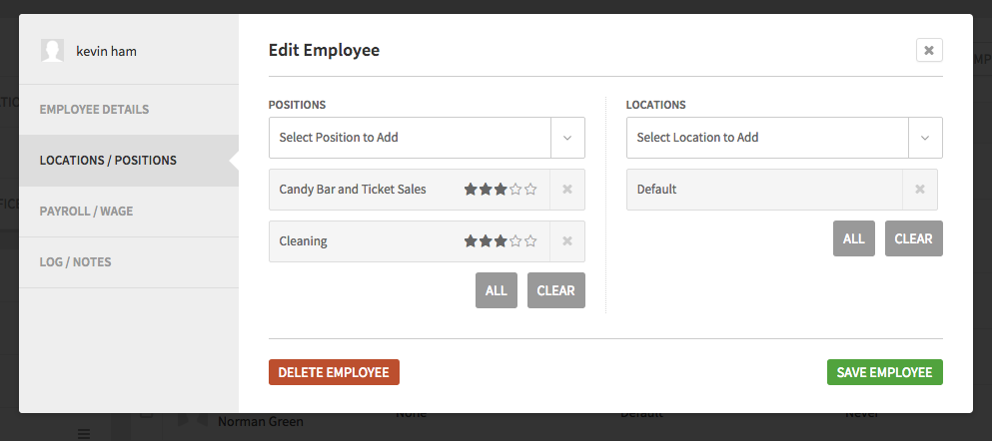

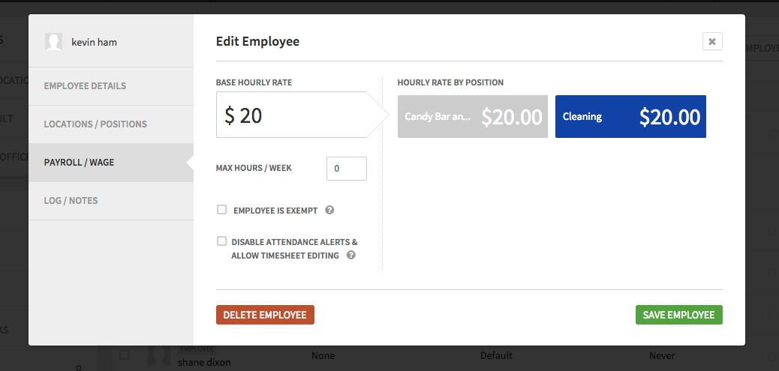

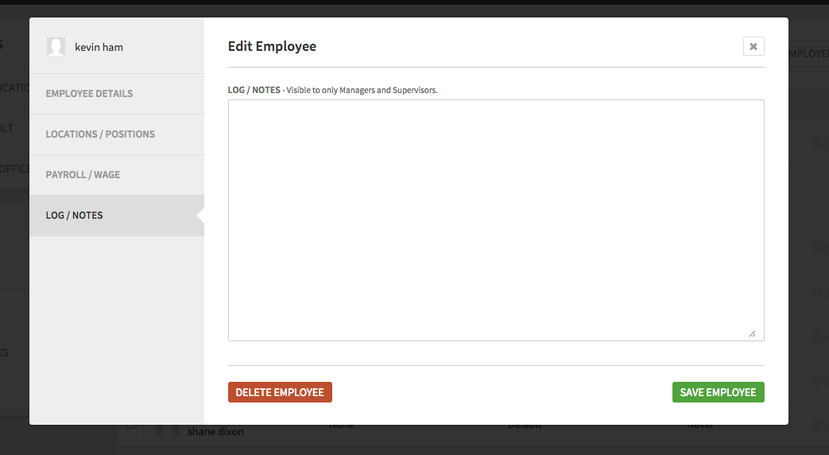

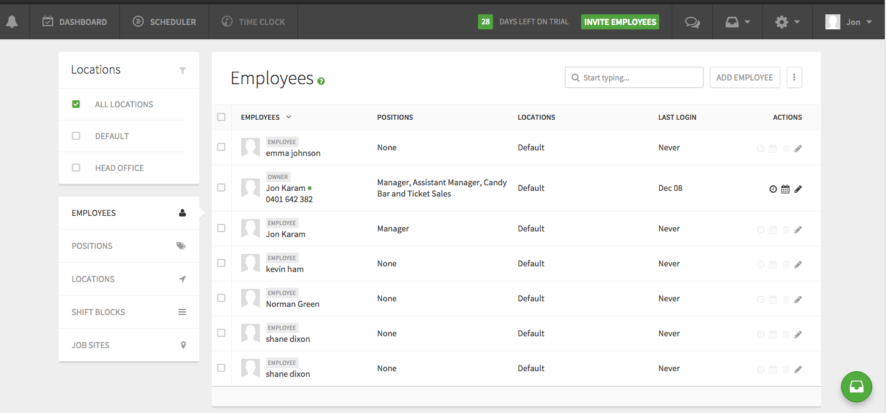

1. My Profile: WIW Features to cover:
   1. Personal data
   2. Sleep preferences
   3. Preferred hours amount per week
   4. Option for privacy – turn off contact information so it cannot be seen by other co-workers
   5. Change password
   6. Alert preferences: Select media format email or mobile.
      1. Time off requests
      2. Swap/drop shifts
      3. Schedule updates
      4. New employee
      5. Availability
      6. Shift reminders – set the time limit for an alert before the start of a shift

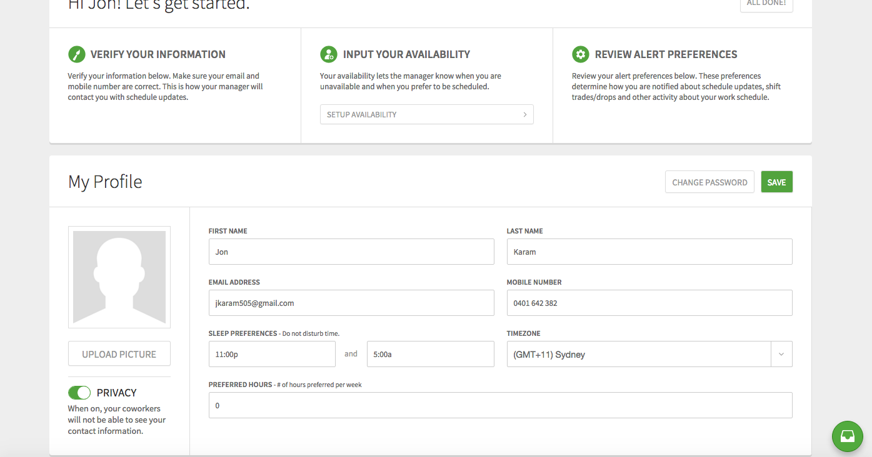

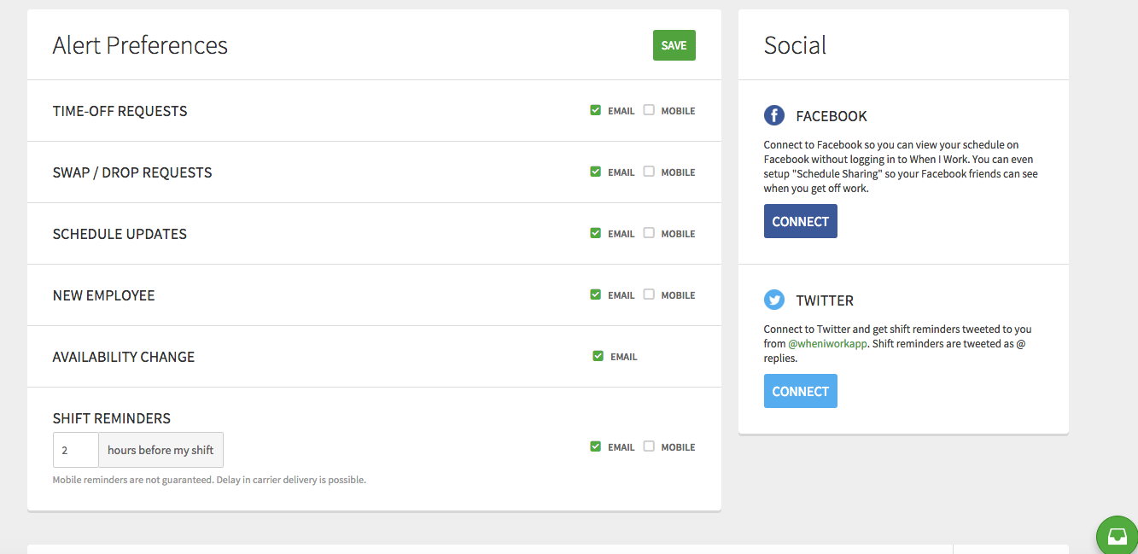

1. Be able to delete employees from departments etc.
2. Change to Australian spelling Organisation ….. no ‘z’.
3. Define privilege settings:
   1. Owner/General Manager
   2. Manager
   3. Supervisor
   4. Employee
4. Emergency Protocols:
   1. Have a tab that will generate a live list of who is currently logged into their shift. Then this list can be used to account for employees at the emergency muster point. Have a slide toggle next to the name to show if present or not.
   2. Contact list, have a drop down menu of selectable contact titles.
      1. Electrician
      2. Plumber
      3. Refrigeration Technician
      4. General Manager
      5. Supervisor
      6. Manager
      7. Equipment Specific Technician
   3. Procedures
      1. We list different instructions in this type. The input field for adding Procedures should be a text box where we type the instructions
5. Views for the ShiftMaker (Scheduler):
   1. Employee orientated
   2. Branch/Location orientated
   3. Position/role orientated
   4. Site orientated – for offsite shifts like in the construction industry.

Have the view similar to WIW

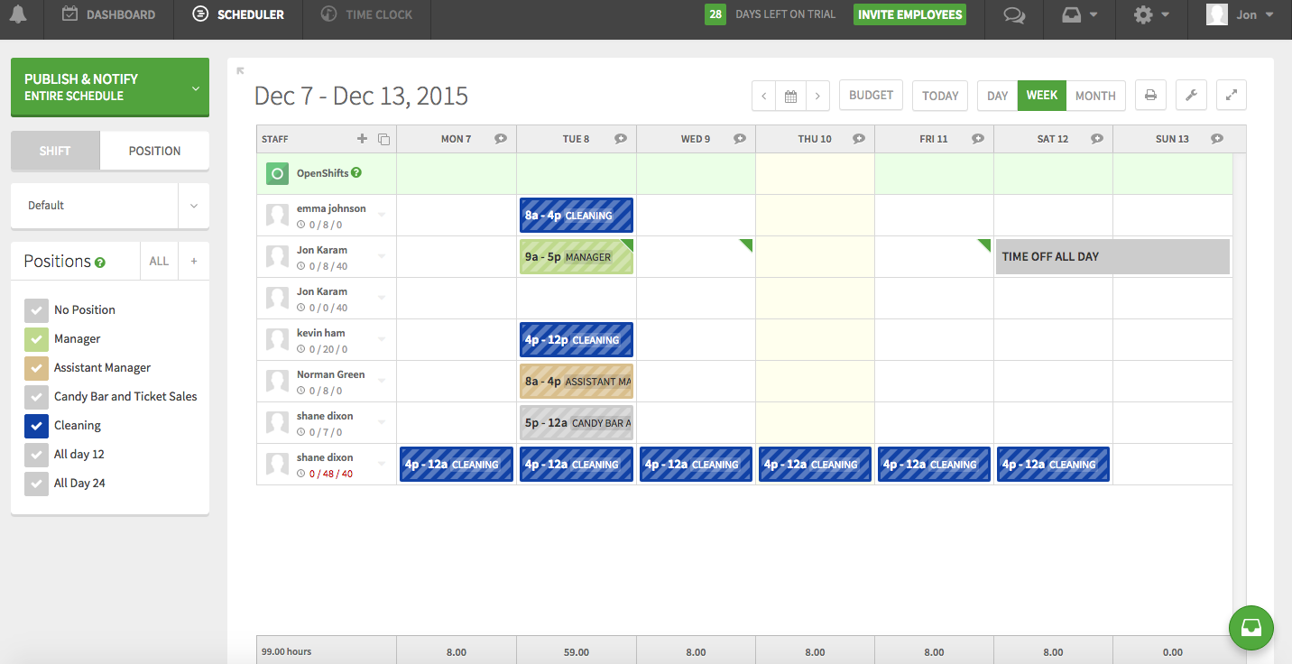

1. Features of the ShiftMaker:
   1. The aim is to have the ability to do everything and access all info required from this page.
   2. Show the availability and preferred work times of the employee similar to When I Work (WIW), see screen shot.
   3. The left hand side has the control panel. This can be collapsed to show ShiftMaker in full screen.
   4. Toolbox menu is in the main header as with WIW.
      1. Copy previous week or fortnight
      2. Clear schedule
      3. Save template
      4. Show only filtered employees
      5. Export schedule
   5. Publish widget, used to publish:
      1. Shift Schedule
      2. Changes to Schedule
      3. Notifications about the schedule
      4. Be able to select by: Organisations, Branches/Locations, Sites, Positions/Roles, Individual Employees.
   6. On WIW scheduler, I like the feature below the name that show the number of hours allocated to the person for the week, hours that have been completed. They turn red if the person is in overtime. We need something like this.

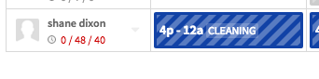

* 1. Question: can we do similar to Excel where you can grab the corner of a cell and then drag it across other cells so it will populate them as well? This would be an easy way to create a shift as you drag across the page in day or week view.

1. Date and time:
   1. 12 hour and 24 hour setting.
      1. 12 hour: 12a through to 12a, 12p = Midday, 12a = Midnight
      2. 24 hour: 0:00 through to 0:00, 0:00 = Midnight, 12:00 = Midday.
   2. Change the date configuration to day, month year.
2. When logged in as a user:
   1. Cannot delete a message from the Message Inbox.
3. MY Profile:
   1. Here are two screen shots from When I work



